ASSIGNMENT FIVE
DUNKIN’ DONUTS CASE STUDY

Dunkin’ Donuts has become an American dream. They started as a small donut shop in Massachusetts, then grew into a global business generating more than $800 million in revenue in 2015. During that growth, Dunkin’ Donuts was acquired by Baskin-Robbins owner Allied Lyons, and then sold to a private equity consortium of Bain Capital, Carlyle Group, and Thomas H. Lee Partners for 2.4 Billion (Dunkin’ Donuts, n.d.). During the middle of their acquisitions, they began ‘Project Freshstart’ to upgrade all of their business processes. These upgrades would eventually lead to rapid growth by driving business process changes using leading-edge tech without lots of customizations. The text quotes that their first change was the implementation of the SAP business suite from Deloitte Consulting because of their track record with wholesale distribution and a strong tech platform that was flexible and could serve as the groundwork for future expansion.
The structure of Dunkin’ Donuts is hierarchical in nature with top-level executives (including managers and supervisors ) and bottom level executives (Dunkin’ Donuts, n.d.). One considerable way to accentuate growth without massive technological changes would be to lower the franchisee purchase amount. Currently, “Dunkin’ requires that one single candidate personally meet their financial qualifications, as well as an initial franchise fee of $40k to $90k.”(Daszkowski, 2019). The current ownership structure appears to be profitable per the trading information from NASDAQ:
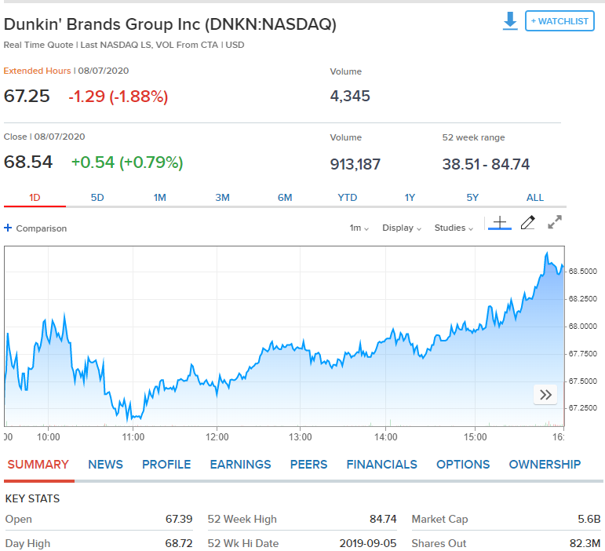
There are three reasons why stakeholders would consider increasing investing in Dunkin’ Donuts:
- “A shift in product focus opens up a new group of customers:
  - If Dunkin' can continue penetrating the specialty coffee beverage market and deliver on its promise of faster and more affordable options while maintaining comparable quality, Starbucks could be in a latte trouble.
- U.S. Sales Growth Signals A Healthy brand:
  - Comparable-store sales growth is up 1.5% this quarter, year over year.
  - Total revenue is up by $9.1 million, a 5.8% increase year over year.
- International Growth Cant Be Ignored:
- Dunkin' International comparable-store sales growth is up 7.3%.
- Total revenue is up $493,000, a 7.9% increase year over year.
- Systemwide sales are up 8.2%. When adjusted on a constant-currency basis, this figure jumps to 11%.(Munarriz, 2020).”
Stakeholder investing can be tricky but has a host of advantages. Potential pitfalls and disadvantages can be “costly investment, access to a limited territory, strict operations guidelines, risk of reputation, and limited exit strategy. (Brookins, n.d.).”
The communication and change management aspects of this project was sufficient as long all of the channels between upper. Middle, and lower management was systematic in the planning, implementing, and monitoring.

References
Dunkin’ Donuts. N.d. “Dunkin’ Donuts.” Wikipedia. Retrieved from: https://en.wikipedia.org/wiki/Dunkin%27_Donuts#:~:text=items%20were%20introduced.-,The%20chain%20was%20acquired%20by%20Baskin,owner%20Allied%20Lyons%20in%201990.&text=In%20December%202005%2C%20Dunkin'%20Donuts,Lee%20Partners%20for%20%242.4%20billion.
Dunkin’ Donuts. N.d. “Dunkin’ Donuts Term Paper”. Retrieved from: https://mid-terms.com/dunkin-donuts-term-paper/
Daszkowski, D. 27 Oct 2019. “Pros and Cons of Buying A Dunkin’ Donuts Franchise”. Retrieved from: https://www.thebalancesmb.com/dunkin-donuts-franchise-review-1350261
Munarriz, R. 01 Jul 2020. “3 Restaurant Stocks To Avoid In July.” Retrieved from: https://www.fool.com/investing/2020/07/01/3-restaurant-stocks-to-avoid-in-july.aspx
Brookins, M. n.d. “The Disadvantages of Franchises.” Retrieved from: https://smallbusiness.chron.com/disadvantages-franchises-186.html

